Sample two-week summer menu for long day care
Early childhood services
The following sample two-week summer menu is based on the Menu planning guidelines for long day care.
Use this sample menu as a guide for developing a healthy menu for children which tastes great and meets their nutrition needs.
The meals featured in the sample menu (for morning tea, lunch and afternoon tea) provide children in long day care who are over the age of one year with all the foods and drinks they need to meet their nutritional needs.
Key information about the sample menu
The two-week menu cycle includes at least:
- 4 red meat meals
- 2 pork or poultry meals
- 2 fish meals
  - 1 vegetarian meal
Each day provides a child with:
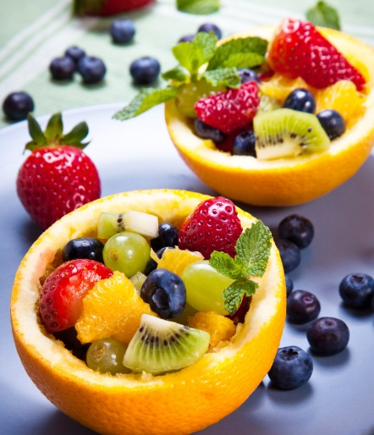
- 1 children’s serve of fruit
- 1–1½ children’s serves of vegetables and legumes/beans
- 1 children’s serve of lean meat, poultry, fish, eggs, legumes and nuts (if allowed)
- 2 children’s serves of milk, yoghurt, cheese and alternatives
  - 2 children’s serves of grain (cereal) foods
For information about children’s serving sizes, please refer to the Menu planning guidelines for long day care at www.heas.health.vic.gov.au.
The menu does not include any of the following discretionary foods or drinks:
- Chocolate, confectionery, jelly
- Sweet biscuits, high fat/salt savoury biscuits, chips
- Cream, ice cream
- Deep fried foods (e.g. hot chips) and pastry based foods (pies, sausage rolls, pinwheels and pasties)
- Most fast food and takeaway foods
- Some processed meats, (e.g. sausages, frankfurts/hot dogs, salami, Strasbourg, Devon, some commercial chicken nuggets and fish fingers)
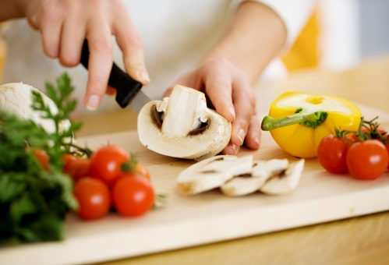
  - Soft drinks, fruit juice and fruit drinks, cordial, sports drinks, energy drinks, flavoured milk and flavoured mineral water
The menu is varied and considers special dietary needs
- Infants over the age of 6 months are provided with iron rich foods, and meals and snacks of progressing texture according to their age.
- Children with allergies are provided with appropriate substitutes of foods and drinks, in line with the Menu planning guidelines.
- The menu includes a variety of meals from different cultures and a variety of tastes, colours, textures and flavours.
  - Main meals are not repeated in the two-week menu cycle and the main ingredient in a meal is not repeated on the same day each week.
Additional important information
- This sample menu should be used as a guide. If you would like to adapt this sample menu for your service, please use the Menu planning guidelines to ensure you provide adequate serving sizes for each child.
  - The recipes in the sample menu below that are in bold are on the Healthy Eating Advisory Service website www.heas.health.vic.gov.au.

(Name of centre) summer menu
WEEK 1 |  | MONDAY | TUESDAY | WEDNESDAY | THURSDAY | FRIDAY
BREAKFAST |  | Choose from: Wholegrain cereals (wheat biscuits, dried fruit and flake mix), porridge and wholemeal toast with healthy toppings, served with milk and water
MORNING TEA | Food | Fresh fruit platter (apple, nectarines, grapes, banana) with pineapple and yoghurt dip | Rainbow platter (banana, rockmelon, plum, beans, cucumber, red capsicum)  Cheese cubes | Fruit smoothie small (100mL)  Fruit toast with ricotta cheese | Fresh fruit platter (apple, nectarines, grapes, banana) with pineapple and yoghurt dip | Yoghurt, summer sunshine salad (peach, nectarine, passionfruit, mint) and (untoasted) muesli
MORNING TEA | Drink | Milk and water | Milk and water | Milk and water | Milk and water | Milk and water
LUNCH | Food  (include  ingredient details) | Chicken curry (Main ingredients: chicken, brown rice, carrots, pumpkin, green beans, canned tomatoes, curry spices and yoghurt) | Beef lasagne with fresh salad (Main ingredients: beef mince, brown lentils, carrot, celery, zucchini, canned tomatoes, ricotta, lasagne sheets, cheese) | Beef and vegetable rissoles with pita bread and salad (Main ingredients: lean beef mince, potato, carrot, zucchini, capsicum, egg, pita bread, salad vegetables) | Creamy tuna pasta bake (Main ingredients: canned tuna, pasta, broccoli, corn, carrot, evaporated milk) | Vegetarian fried rice (Main ingredients: egg brown rice, carrot, capsicum, spring onion, peas, corn, reduced salt soy sauce,)
LUNCH | Drink | Water | Water | Water | Water | Water
AFTERNOON TEA | Food | Toasted wholemeal English muffins with sliced tomato and cheese  Rockmelon wedges | Fruity crumble (wholemeal flour, oats, cooked seasonal fruits) served with Greek yoghurt | Rice cakes and toppings (cottage cheese, sliced tomato, cucumber)  Watermelon and friends platter (watermelon triangles, grapes, strawberries) | Make your own pizza faces (wholemeal pita bread, salt reduced tomato paste, shredded chicken breast, mushroom, tomato, capsicum, cheese) | Vegetable sticks (beans, celery, carrot) with creamy corn and tuna dip and wholemeal crackers  Watermelon and friends platter (watermelon triangles, grape, strawberries)
AFTERNOON TEA | Drink | Milk and water | Milk and water | Milk and water | Milk and water | Milk and water
LATE SNACK |  | Choose from: wholegrain crackers and cheese, fresh vegetables and fruit, served with water
Water |  | Water is freely available throughout the day
Infants (eating solids) |  | A variety of healthy foods are offered every day including iron-rich foods (meat, poultry, fish, legumes/beans, tofu, eggs), fruit, vegetables, grains and milk products. Foods are an appropriate texture for infants’ age (e.g. mashed, lumpy, chopped, finger foods).
Allergies |  | Children with allergies and or food intolerances are provided a tailored version of the regular menu to suit their individual needs

(Name of centre) summer menu
WEEK 2 |  | MONDAY | TUESDAY | WEDNESDAY | THURSDAY | FRIDAY
BREAKFAST |  | Choose from: Wholegrain cereals (wheat biscuits, dried fruit and flake mix), porridge and wholemeal toast with healthy toppings, served with milk and water
MORNING TEA | Food | Rainbow platter (apple, banana, cherry tomatoes, carrot, cucumber)  Wholegrain crackers with white bean dip | Rainbow platter (nectarines, rockmelon, pineapple, beans, carrot)  Wholegrain crackers with chickpea and beetroot dip | Banana bubbles  (banana rolled in yoghurt, rice bubbles) | “Melon Head” platter (watermelon, honeydew, rockmelon) with pineapple and yoghurt dip | Wholemeal toast with ricotta cheese, sliced banana and cinnamon
MORNING TEA | Drink | Milk and water | Milk and water | Milk and water | Milk and water | Milk and water
LUNCH | Food  (include  ingredient details) | Mexican beef wraps (Main ingredients: lean minced beef, carrot, capsicum, canned red kidney beans, canned tomato, spices, iceberg lettuce, avocado, cheese, wholemeal wraps) | Tuna and lentil bolognese (Main ingredients: canned tuna, dried red lentils, mixed vegetables, canned tomatoes, wholemeal pasta, cheese) | Falafel balls with tzatziki dip served with wholemeal wraps and salad (Main ingredients: canned chickpeas, cumin, garlic, eggs, fresh herbs, yoghurt, cucumber, salad vegetables) | Beef san choy bau (Main ingredients: rice noodles, lean minced beef, cabbage, carrot, green beans, peas, capsicum, ginger, soy sauce, ice berg lettuce) | Chicken and vegetable stir fry with brown rice (Main ingredients: chicken fillets, cabbage, carrot, capsicum, zucchini, brown rice)
LUNCH | Drink | Water | Water | Water | Water | Water
AFTERNOON TEA | Food | Banana bread served cinnamon spiced ricotta | Spinach and cheese muffins served with fruit smoothie small (100mL) | Veggie dippers (carrot, red capsicum, lightly steamed broccoli), rice cakes served with sweet potato and salmon dip | Platter of wholemeal sandwich triangles:  Cottage cheese, chicken and cucumber  Cream cheese, tuna and corn | Vegetable platter (cucumber, carrot and capsicum) with tzatziki dip and Frozen UFOs (frozen pineapple disks and watermelon triangles)
AFTERNOON TEA | Drink | Milk and water | Milk and water | Milk and water | Milk and water | Milk and water
LATE SNACK |  | Choose from: wholegrain crackers and cheese, fresh vegetables and fruit, served with water
Water |  | Water is freely available throughout the day
Infants (eating solids) |  | A variety of healthy foods are offered every day including iron-rich foods (meat, poultry, fish, legumes/beans, tofu, eggs), fruit, vegetables, grains and milk products. Foods are an appropriate texture for infants’ age (e.g. mashed, lumpy, chopped, finger foods).
Allergies |  | Children with allergies and or food intolerances are provided a tailored version of the regular menu to suit their individual needs

Menu planning guidelines for long day care, Healthy Eating Advisory Service, Department of Health and Human Services, State Government of Victoria, 2013, www.heas.health.vic.gov.au
One children’s serve of fruit is equal to half a serve in the Australian Dietary Guidelines.
One children’s serve of vegetables and legumes/beans is equal to half a serve in the Australian Dietary Guidelines.
One children’s serve of lean meat, poultry, fish or alternatives is equal to half a serve in the Australian Dietary Guidelines.
One children’s serve of milk, yoghurt, cheese and/or alternatives is equal to half a serve in the Australian Dietary Guidelines.
One children’s serve of grain (cereal) foods is equal to half a serve in the Australian Dietary Guidelines.

